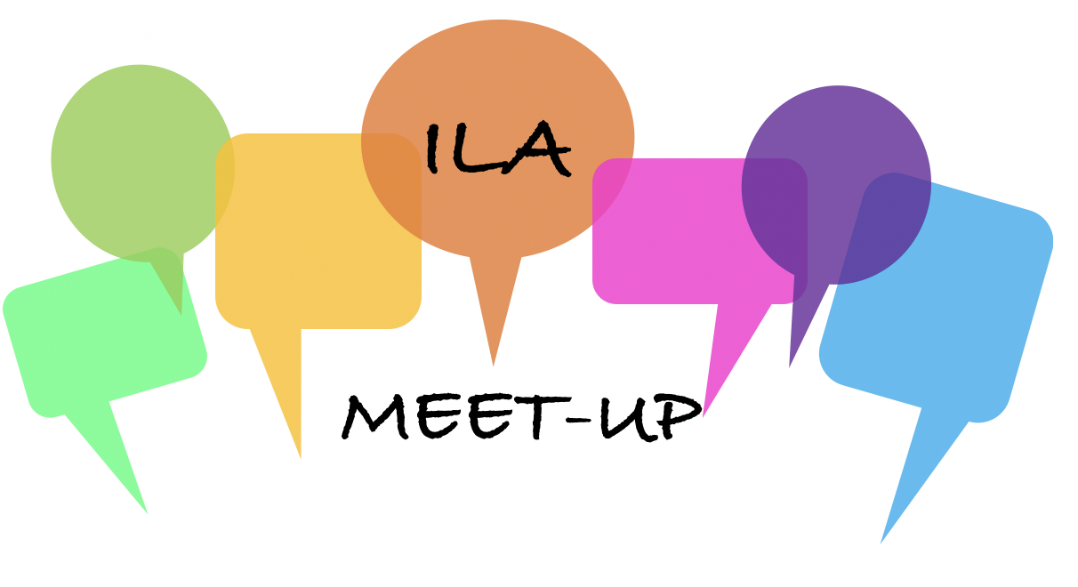
How to propose an ILA MEET-UP
The ILA Meet-Up is an online event to provide ILA members with a more casual opportunity to “Meet-Up” to discuss their projects, interests, concerns, or - just be social. The aim is to enable members to get to know each other.
If you have an idea for a Meet-Up topic, the ILA invites you to propose it here.
- Complete proposal form below
- If you have questions, please contact Sandra Bodin-Lerner

Program Proposal Form

Speaker(s) Name and Title
Speaker(s) Bio
Title of Program
Objective
- What will the audience gain from the program?
- What is your personal objective?
Topic Description: (please be specific)
- Describe every aspect of your presentation (beginning, middle, end)
- Explain how the program will be interactive.
- Share any specific technical needs.
- How will the program be engaging and informative?
- Length?
Intended audience
- Who should attend?
- How many people can participate?
Return completed form to Sandra Bodin-Lerner
What happens next:
- We will contact you to discuss your proposal and select a Meet-Up date.

